Week 13: Correlation, Regression

Data 8 Tutoring

# 1 Correlation

## Key Concepts

**Association**

* Refers to any relationship between two variables. It does not have to be linear. For instance, in the plots below, only the first graph demonstrates a linear association.

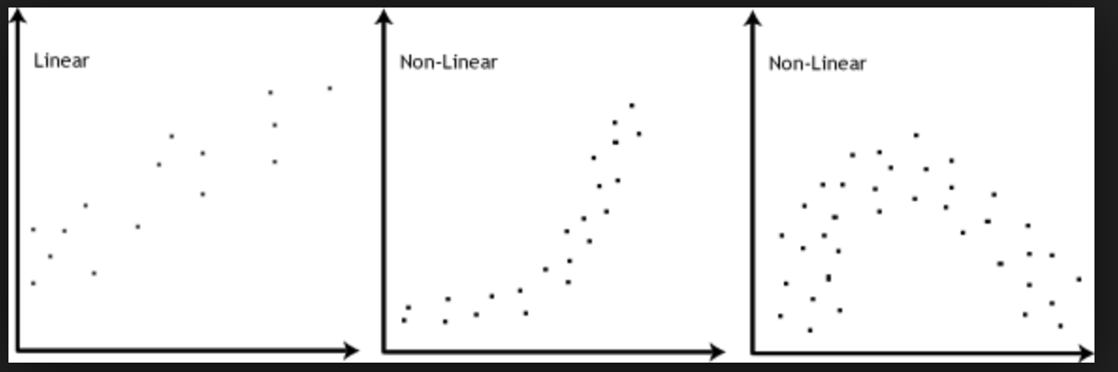

**Correlation**

* Denotes a linear association between two variables.
* The *correlation coefficient* quantitatively measures the strength as well as the direction of the linear relationship between two variables.
* The correlation coefficient is denoted as *r*, a number between -1 and 1
  + Strength: how clustered the scatter plot is around a straight line. If the plot is highly clustered, the absolute value of *r* is closer to 1
  + Direction: if y increases as x increases, *r* is positive. If y decreases as x increases, *r* is negative.

**Standard Units**

* Allows us to quantify the relationship between two variables on different scales
* Converting to Standard Units
  + variable_su = (variable – mean) / SD

**A Formula for r**

* The average of the product of *x* and *y*, when both variables are measured in standard units.
* r = 1 if the scatter diagram is a perfect straight line sloping upwards, and r = −1 if the scatter diagram is a perfect straight line sloping downwards.
* r is *a number without units*. This is because it is computed with standard units, which have no units.
* r is *unaffected by changing the units* on either axis. This too is because r is based on standard units.
* r is *unaffected by switching the axes*. This is because it is the sum of products of standard units; xy = yx. More intuitively, since correlation is a measure of spread around a line, switching the axes won’t change the spread around the line.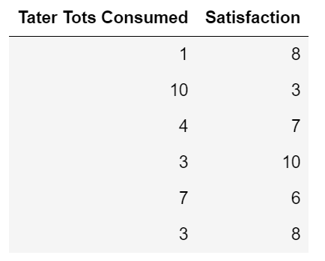

## Practice Problems

**1.1** The following table, taters, depicts the number of tater tots a person has ate, along with a number that quantifies their satisfaction, which is a number that goes from 0 to 10.

a) Complete the function standard_units which takes in an array num_array and returns the same array in standard units.

def standard_units(num_array):

arr_mean = _________________________________

arr_sd = ___________________________________

return _____________________________________

b)Fill in the blanks to define a function correlation that finds the correlation from a table. It takes in three arguments: a table, tbl, and two column indices, x and y.

Hint: Use the standard_units function defined above!

def correlation(tbl, x, y):

su_x = __________________(_______________________)

su_y = __________________(_______________________)

return _____________(____________________________)

c) Calculate r by using the correlation function.

correlation(_____________, _____________, _____________)

d) Suppose that we calculated a value of *r* to be equal to -0.879. What can you conclude about the association between the number of tater tots consumed and a person’s satisfaction?

**1.2** True or False?

a. A high value of *r* shows that a change in *x* causes a change in *y*.

b. If we switch the axes of a plot, the correlation coefficient will not change.

c. Suppose that we calculated a value of *r* to be equal to .83. We should conclude that eating taters is indeed correlated with satisfaction.

**1.3** Answer the following questions about the plots below.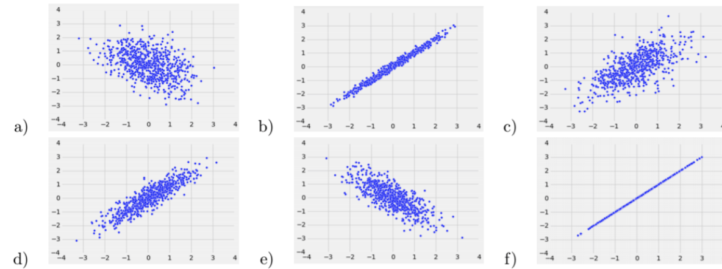

1. Order the scatter plots above in from least correlated to most correlated.
2. Which plots have a positive correlation coefficient? Negative correlation coefficient?

# 2 Regression

## Key Concepts

**Correlation Coefficient**

* The equation for the data’s regression line can be calculated using *r*. Recall that the equation of a line is y = slope · x + intercept.

**Standard Units**

* Graphically, the scatterplot and regression line look the same whether x and y are in standard units or their original units.
* Calculating the regression line when *x* and *y* are in standard units:
  + estimate of *y* = *r* ⋅ the given *x*,where *x* and *y* are in standard units

**Calculating the regression line when *x* and *y* are in original units:**

1) Calculate the correlation coefficient, *r*.

2) Calculate the slope.

slope of the regression line

3) Calculate the intercept.

intercept of the regression line $= average of y - slope*average of x$

## Practice Problems

The water table contains one row per country with data from 2014. The OBS_VALUE column represents the approximate price ranking of a 1.5 liter bottle of mineral water in that country, and the mm_precipitation column represents the average precipitation in that country (in millimeters).

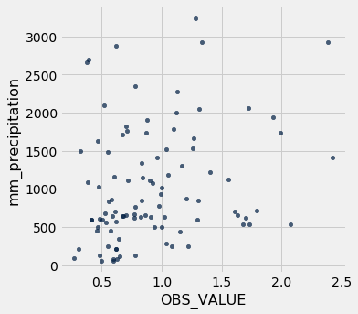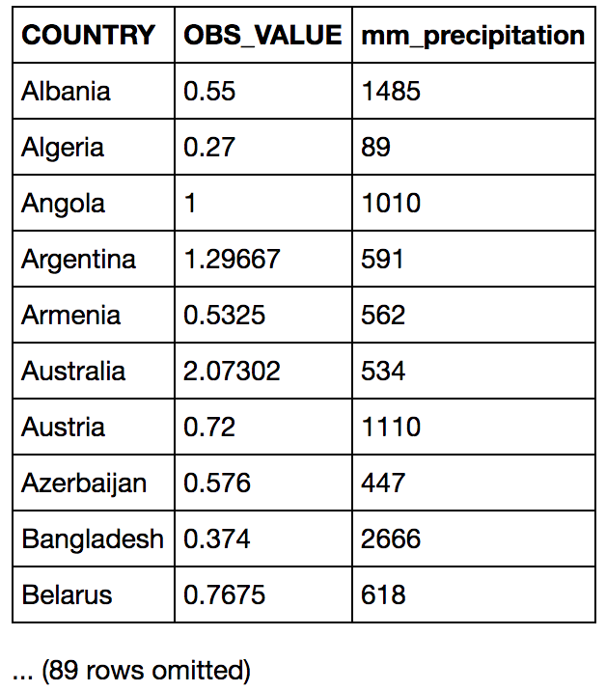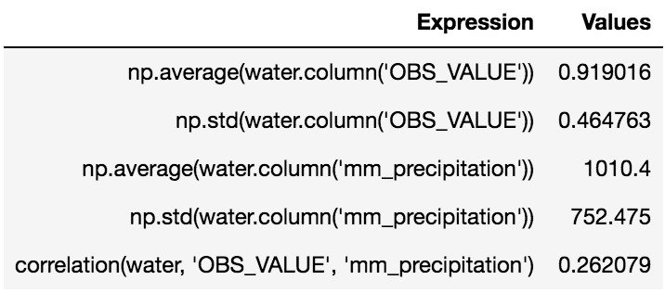

**2.1** What is the value of correlation(water, ‘mm_precipitation’, ‘OBS_VALUE’)?

**2.2** Write an equation for the regression line of the data in the water table, using OBS_VALUE as *y* using the mm_precipitation as *x*.

**2.3** Using the regression line equation above, what would we expect the OBS_VALUE to be in 2014 for a country that had an average of 700 mm of precipitation?

# 3 Root Mean Squared Errors (RMSE)

## Key Concepts

* Root Mean Squared Error is the square root of the average of the squared errors
* RMSE $= \sqrt{(erro{r_{0}}^{2}+erro{r_{1}}^{2}+...+erro{r_{n}}^{2}) / n}$, where *n* is the number of points in our dataset and each $error = actual value - predicted value$

|  |  |  |
| --- | --- | --- |
| Original Plot | Poor Fit (High RMSE) | Best Fit (Lowest RMSE) |
|  |  |  |

## Practice Problems

**3.1** Write a function that returns the RMSE of an array of observed values if the predicted values are given by an array. The two arrays have the same length.

def RMSE(observed, predicted):

residual = ____________________________________

squared_residuals = _______________________________________

squared_resid_avg = _______________________________________

return ________________________________________

**3.2** In the calculation of root mean squared error, why is it important for us to square the residual before taking the sum?